**Experiment 9–Configure Failover Routing with Amazon Route 53**

**AIM:**To configure failover routing with Amazon Route 53.

**PROCEDURE:**

1. Firstly, open the AWS console homepage on browser (<https://aws.amazon.com/console/> ).

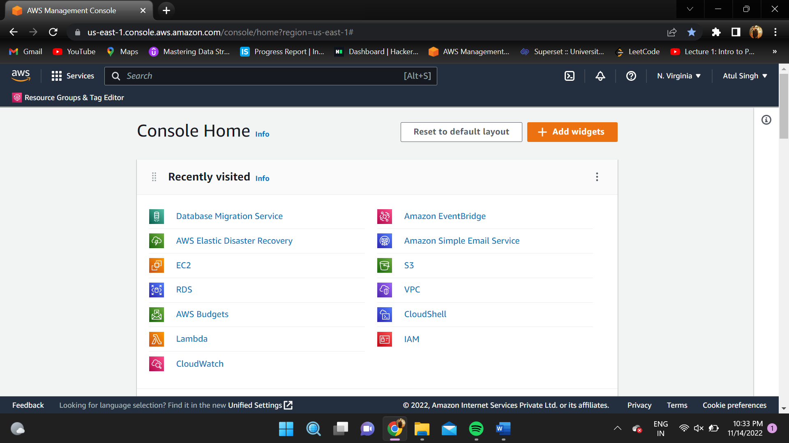

1. Create a Public webserver in region 1.

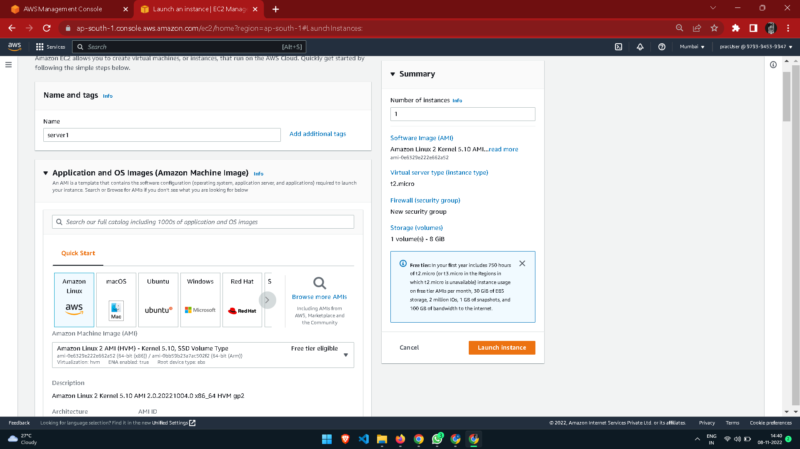

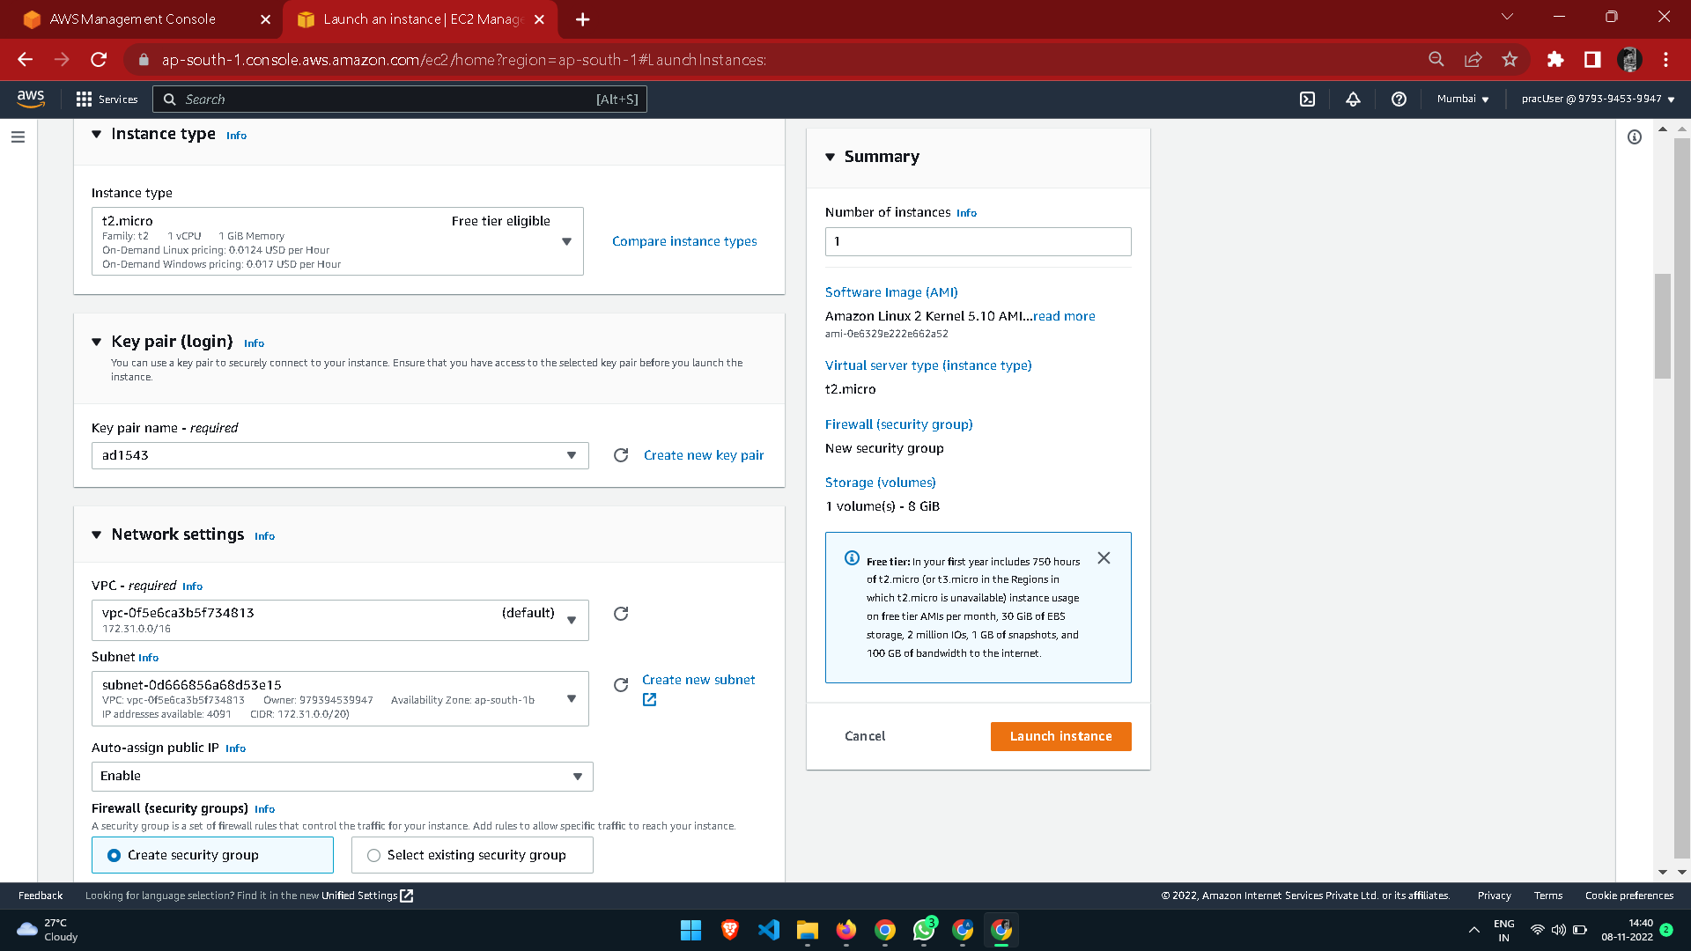

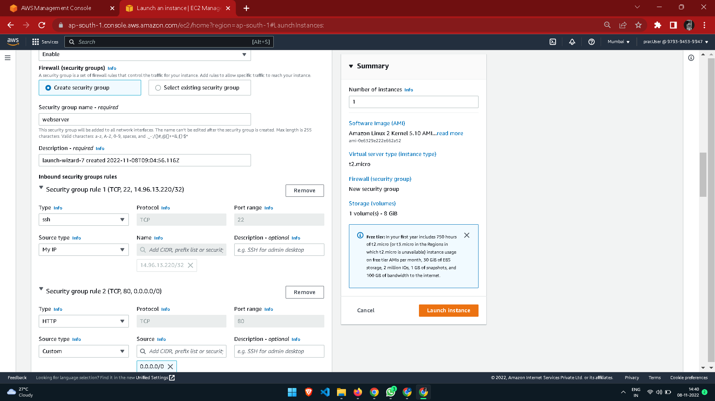

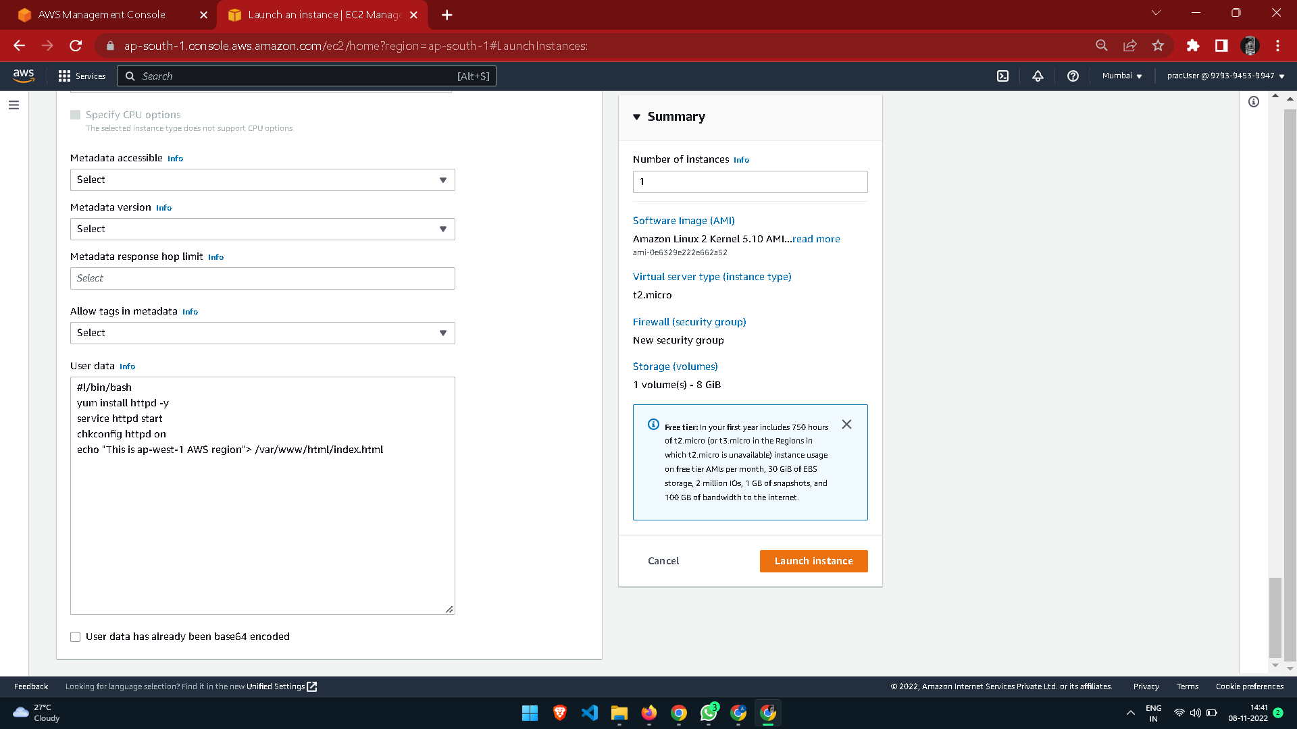

1. Create a public webserver in region 2.
2. Create a Route53 public hosted zone (e.g.: Yourdomain.com).
3. Create 2 health checks for both the webservers.

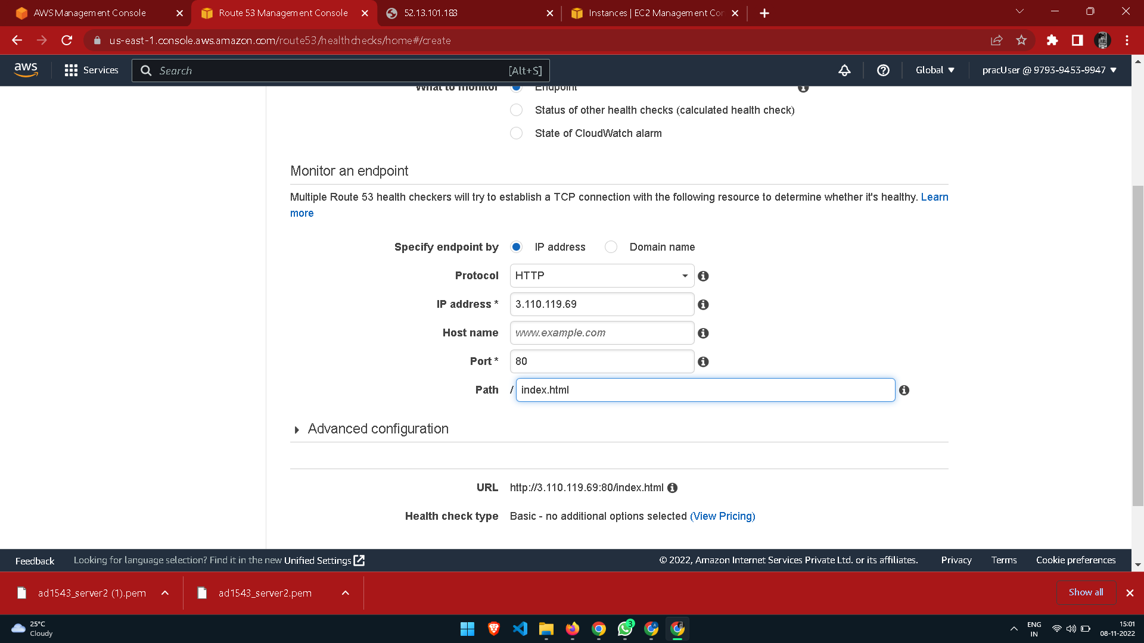

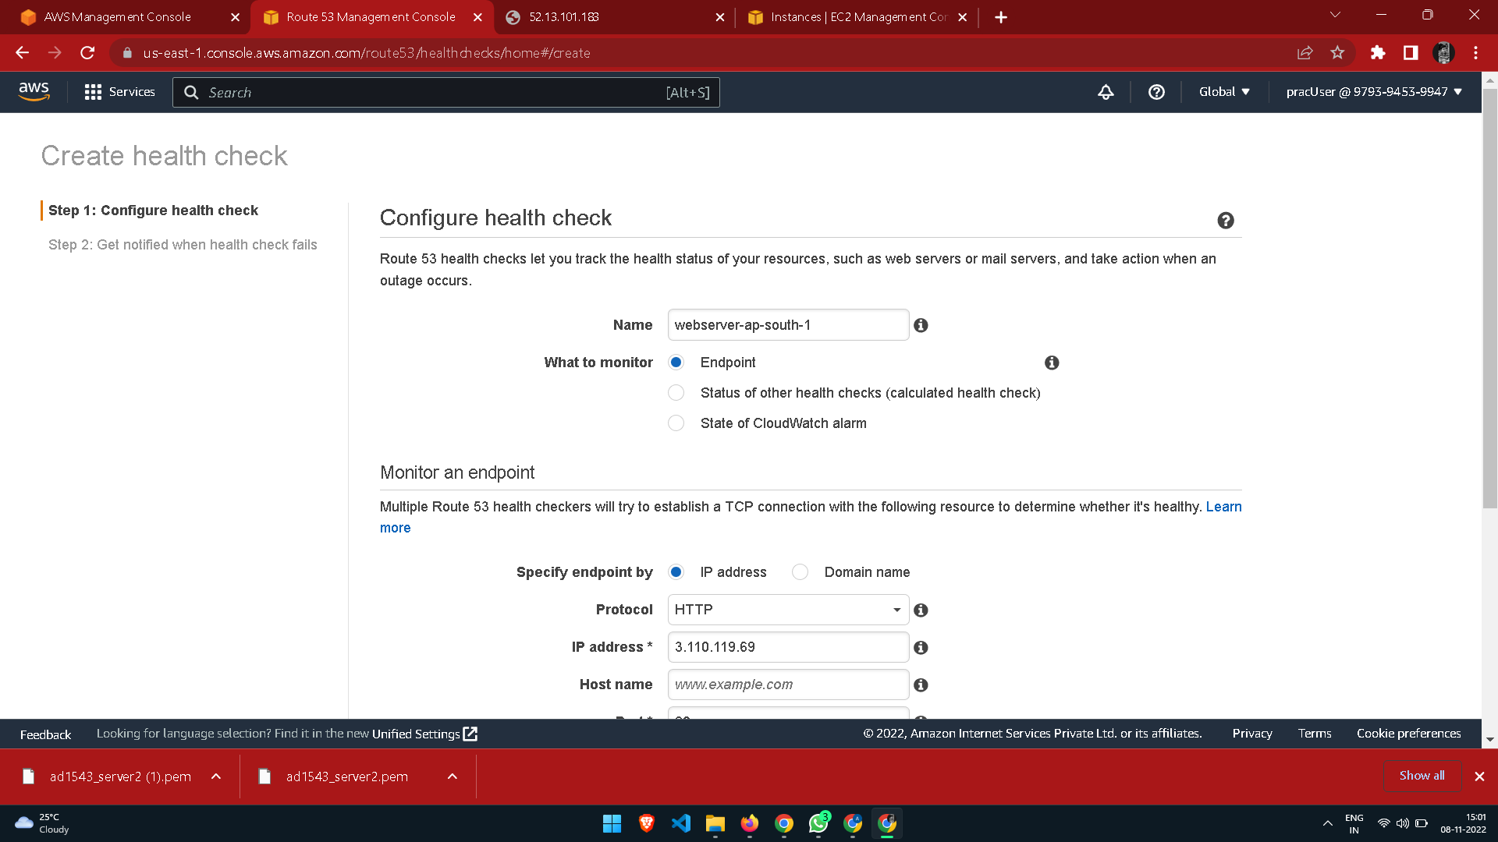

1. Create a subdomain A record test.yourdomain.com and configure it as failover routing (Primary).

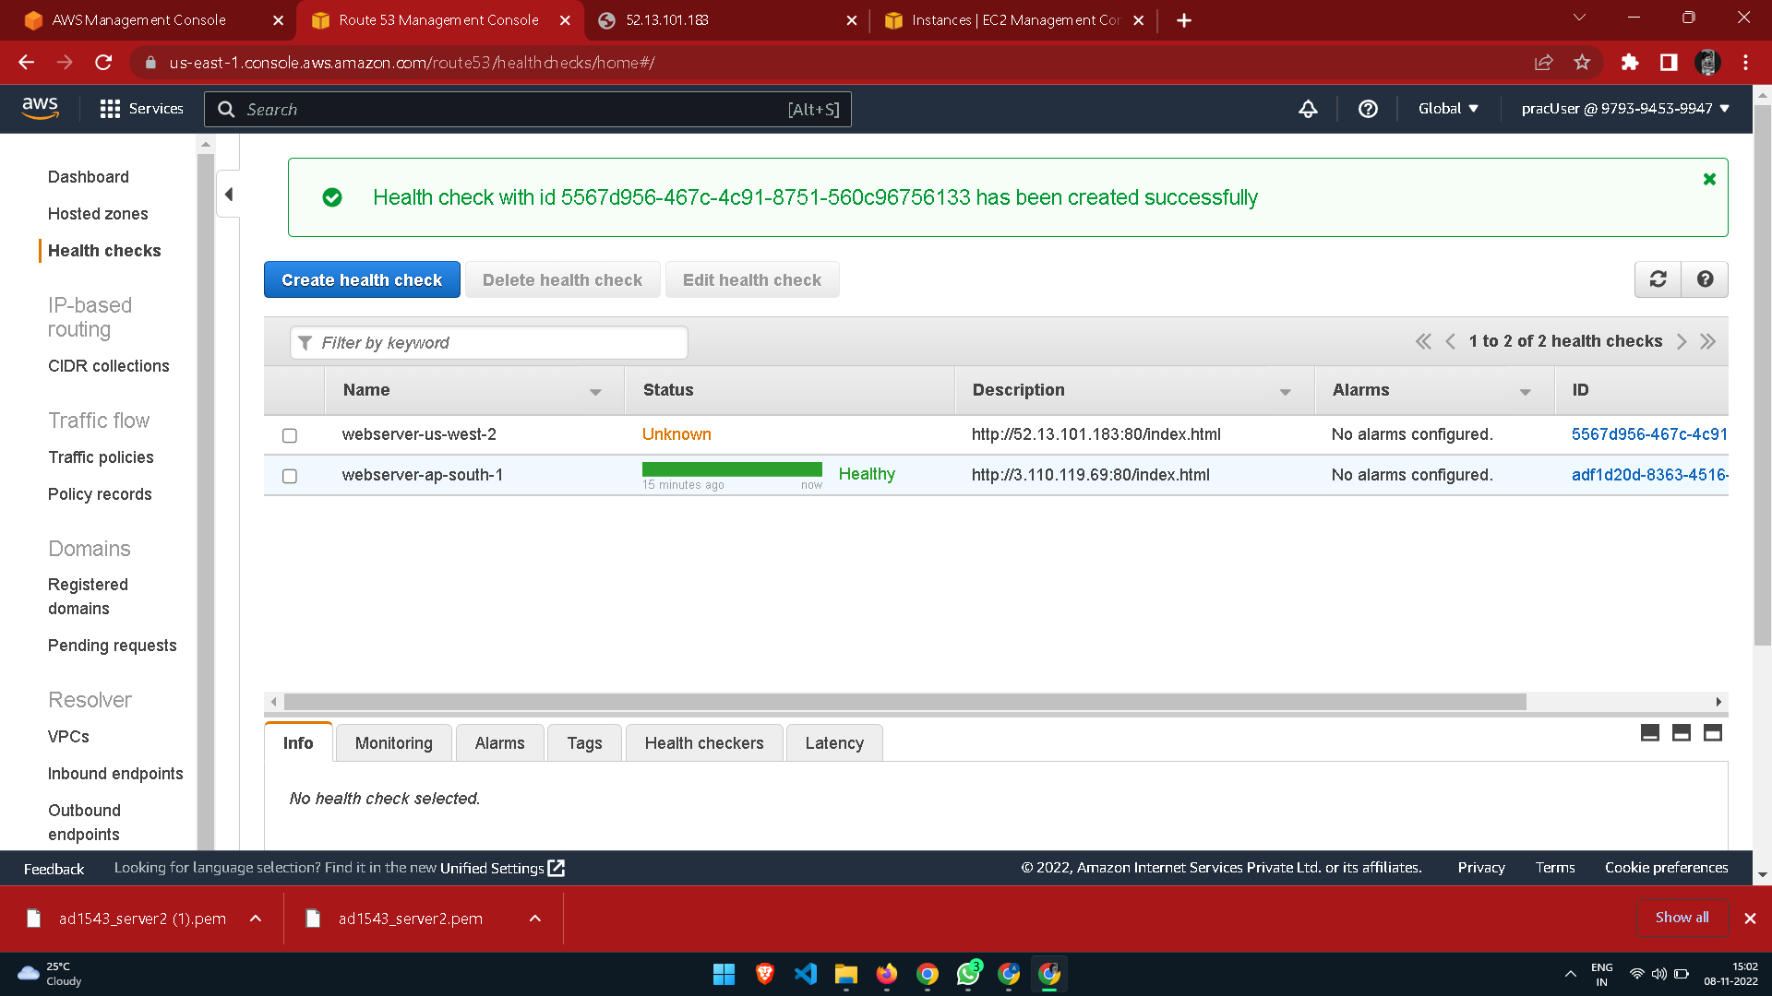

1. Create another same subdomain A record test.yourdomain.com and configure it as failover routing (secondary).

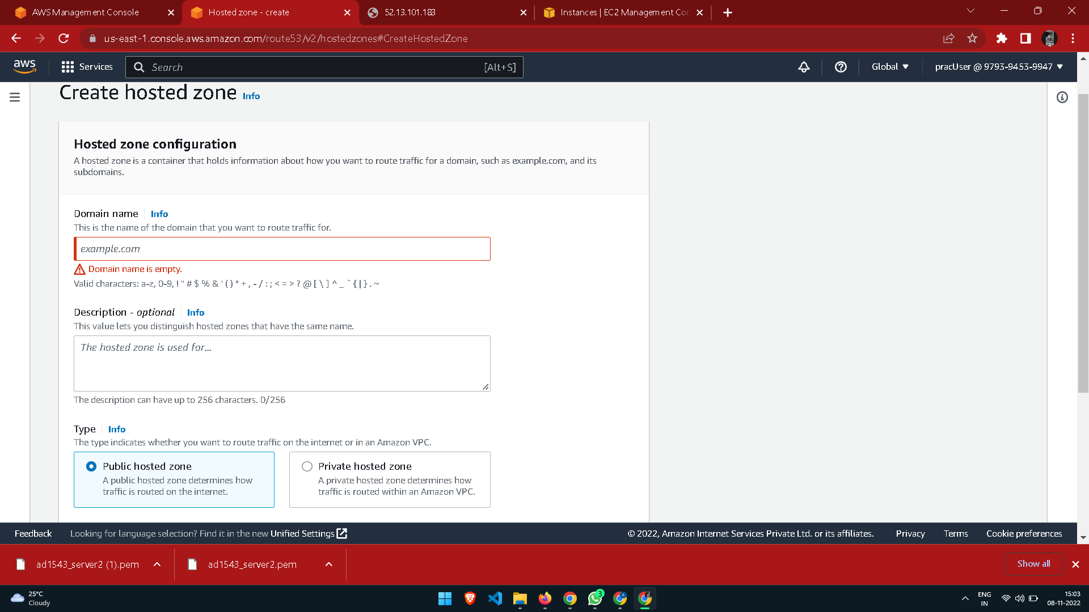

1. Test the connection by hitting http://test.yourdomain.com.
2. Login to primary webserver in region 1 and stop httpd service.
3. Wait for TTL to expire and see If you get redirected to another web server in region 2.

**RESULT:**

A failover routing with Amazon Route 53 was configured successfully.